 | 18.1.7 Editors - Graph Editor - Key Menu
Table of content
Graph Editor - Key Menu 4
Transform 4
Snap 7
Mirror 8
Insert Keyframes 8
Jump to Selected 9
Copy Keyframes 9
Paste Keyframes 9
Paste Flipped 9
Duplicate 9
Delete Keyframes 10
Decimate (Ratio) 10
Decimate (Allowed Change) 10
Slider Operators submenu 11
Clean Keyframes 12
Clean Channels 12
Smooth Keys 13
Sample Keyframes 13

Detailed table of content
Detailed table of content
Graph Editor - Key Menu 4
Transform 4
Grab/Move 4
Last Operator Move 4
Move X, Y Z 4
Orientation 4
Proportional editing 4
Proportional Falloff 5
Proportional Size 5
Connected 5
Projected(2D) 5
Extend 5
Last Operator Transform 5
Values X, Y Z, W 5
Axis 5
Orientation 5
Proportional editing 5
Proportional Falloff 5
Proportional Size 5
Connected 5
Projected(2D) 6
Rotate 6
Last Operator Rotate 6
Angle 6
Axis 6
Orientation 6
Proportional editing 6
Proportional Falloff 6
Proportional Size 6
Connected 6
Projected(2D) 6
Scale 6
Last Operator Resize 7
Angle 7
Axis 7
Orientation 7
Proportional editing 7
Proportional Falloff 7
Proportional Size 7
Connected 7
Projected(2D) 7
Snap 7
Last Operator Snap Keys 8
Type 8
Equalize Handles 8
Last Operator Equalize Handles 8
Side 8
Handle length 8
Flatten 8
Mirror 8
Last Operator Mirror Keys 8
Type 8
Insert Keyframes 8
Last Operator Insert Keyframes 9
Type 9
Jump to Selected 9
Copy Keyframes 9
Paste Keyframes 9
Paste Flipped 9
Last Operator Paste Keyframes / Flipped 9
Offset 9
Type 9
Flipped 9
Duplicate 9
Last Operator Duplicate 9
Mode 9
Values X / Y 9
Axis 10
Orientation 10
Proportional editing 10
Proportional Falloff 10
Proportional Size 10
Connected 10
Projected(2D) 10
Delete Keyframes 10
Decimate (Ratio) 10
Decimate (Allowed Change) 10
Last Operator Decimate Keyframes 10
Mode 10
Remove or Max Error Margin 10
Slider Operators submenu 11
Breakdown 11
Last Operator Breakdown 11
Factor 11
Blend to Neighbour 11
Last Operator Blend to Neighbour 11
Blend 11
Blend to default Value 11
Last Operator Blend to Default 11
Factor 11
Ease 11
Blend to default Value 11
Last Operator Ease Keyframes 12
Factor 12
Smooth (Gaussian) 12
Smooth (Legacy) 12
Butterworth Smooth 12
Blend to default Value 12
Last Operator Gaussian Smooth 12
Factor 12
Sigma 12
Filter width 12
Clean Keyframes 12
Clean Channels 12
Last Operator Clean Keyframes 12
Threshold 12
Channels 13
Smooth Keys 13
Sample Keyframes 13

Graph Editor - Key Menu
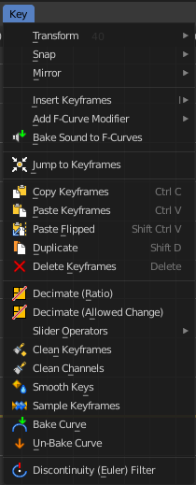
This menu contains functionality to manage the keyframes.

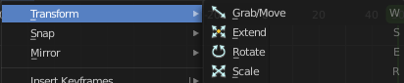
Transform

Grab/Move
Moves the selected keyframe(s).

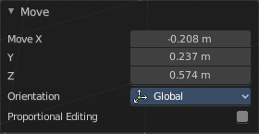
Last Operator Move

Move X, Y Z
The position. Attention, the actual world orientation and rotation does not matter here. It always starts with a value of zero, and moves relative to this zero then. For the actual location values have a look in the sidebar in the transform panel.

Orientation

The widget can have different orientations. The menu items should be self explaining.

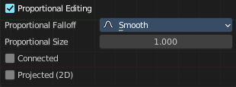
Proportional editing
Enables proportional editing. Activating proportional editing reveals further settings.

Proportional Falloff
Adjust the falloff methods.

Proportional Size
See and adjust the falloff radius.

Connected
The proportional falloff gets calculated for connected parts only.

Projected(2D)
The proportional falloff gets calculated in the screen space. Depth doesn't play a role. When it's in the radius, then it gets calculated.

Extend
Moves the last keyframes of the selection.

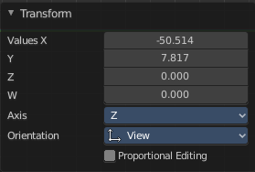
Last Operator Transform

Values X, Y Z, W
The new position.

Axis
Which axis to transform.

Orientation
The widget can have different orientations. The menu items should be self explaining.

Proportional editing
Enables proportional editing. Activating proportional editing reveals further settings.

Proportional Falloff
Adjust the falloff methods.

Proportional Size
See and adjust the falloff radius.

Connected
The proportional falloff gets calculated for connected parts only.

Projected(2D)
The proportional falloff gets calculated in the screen space. Depth doesn't play a role. When it's in the radius, then it gets calculated.

Rotate
Rotates the selection.

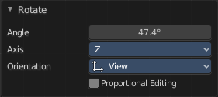
Last Operator Rotate

Angle
The rotation. Attention, the actual world orientation and rotation does not matter here. It always starts with a value of zero, and rotates relative to this zero then. For the actual rotation values have a look in the sidebar in the transform panel.

Axis
Which axis to rotate.

Orientation
The widget can have different orientations. The menu items should be self explaining.

Proportional editing
Enables proportional editing. Activating proportional editing reveals further settings.

Proportional Falloff
Adjust the falloff methods.

Proportional Size
See and adjust the falloff radius.

Connected
The proportional falloff gets calculated for connected parts only.

Projected(2D)
The proportional falloff gets calculated in the screen space. Depth doesn't play a role. When it's in the radius, then it gets calculated.

Scale
Scales the selected keyframes. You need to have more than one keyframe selected.

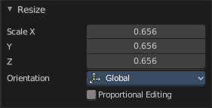
Last Operator Resize

Angle
The rotation. Attention, the actual world orientation and rotation does not matter here. It always starts with a value of zero, and rotates relative to this zero then. For the actual rotation values have a look in the sidebar in the transform panel.

Axis
Which axis to rotate.

Orientation
The widget can have different orientations. The menu items should be self explaining.

Proportional editing
Enables proportional editing. Activating proportional editing reveals further settings.

Proportional Falloff
Adjust the falloff methods.

Proportional Size
See and adjust the falloff radius.

Connected
The proportional falloff gets calculated for connected parts only.

Projected(2D)
The proportional falloff gets calculated in the screen space. Depth doesn't play a role. When it's in the radius, then it gets calculated.

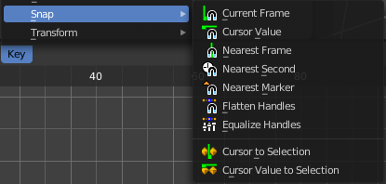
Snap
Snaps the selected keyframes by the chosen method.
Cursor to Selection and Cursor Value to Selection does not have a last operator.

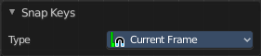
Last Operator Snap Keys

Type
Snaps the selected keyframes by the chosen method.

Equalize Handles
Equalize handles is not really a snap method. And therefore it also has another last operator. The Equalize Handles operator allows users to make selected handle lengths uniform: either respecting their original angle from the key control point or by flattening their angle (removing the overshoot sometimes produced by certain handle types).

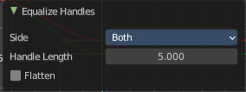
Last Operator Equalize Handles

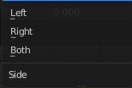
Side
Which side of the control point to affect.

Handle length
How long the handles should become.

Flatten
Equalize the length of the handlers to the other keyframes.

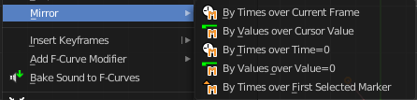
Mirror
Flips the selected keyframes over the current frame position.

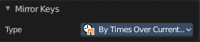
Last Operator Mirror Keys

Type
Flips the selected keyframes over the current frame position by the chosen method.

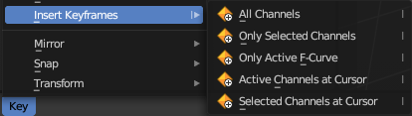
Insert Keyframes
Choose a method how to insert a new keyframe at the current frame position.

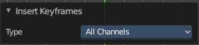
Last Operator Insert Keyframes

Type
Choose a method how to insert a new keyframe at the current frame position.

Jump to Selected
Sets the frame marker at the average position of the currently selected keyframes.

Copy Keyframes
Copy selected keyframes.

Paste Keyframes
Pastes copied keyframes.

Paste Flipped
Pastes copied keyframes, but flipped.

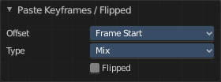
Last Operator Paste Keyframes / Flipped

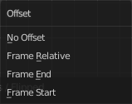
Offset
Define an offset for the paste position.

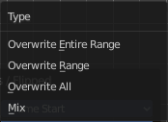
Type
Choose a method how to paste the copied keyframes.

Flipped
Pastes keyframes from mirrored bones if they exists.

Duplicate
Duplicate selected keyframes.

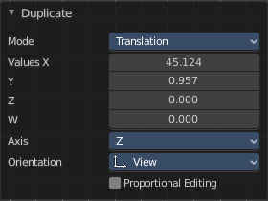
Last Operator Duplicate

Mode

Values X / Y
The x and y values for the pasted keyframes. Note that these values starts at the position of the original copied keyframe. These values are relative.
Values Z and W have no effect here.

Axis
These values have no effect.

Orientation
These values have no effect.

Proportional editing
Enables proportional editing. Activating proportional editing reveals further settings.

Proportional Falloff
Adjust the falloff methods.

Proportional Size
See and adjust the falloff radius.

Connected
The proportional falloff gets calculated for connected parts only.

Projected(2D)
The proportional falloff gets calculated in the screen space. Depth doesn't play a role. When it's in the radius, then it gets calculated.

Delete Keyframes
Deletes selected keyframes.

Decimate (Ratio)
Decimate F-Curves by removing keyframes that that has the least influence to the curve shape.

Decimate (Allowed Change)
Decimate F-Curves by specifying how much it can derivative from the original curve.

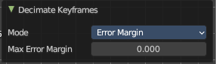
Last Operator Decimate Keyframes
This last operator appears for both decimate operators.

Mode
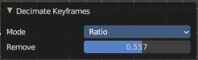
The decimate mode. Error margin is Allowed change.

Remove or Max Error Margin
The percentage of keyframes to remove.

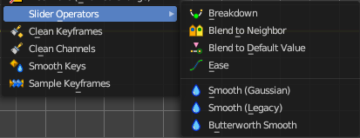
Slider Operators submenu

Breakdown
Relaxes the current pose to an inbetween position between the adjacent keyframes.
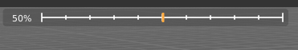
When you perform the tool then you will see a per cent slider in the header where you can read the percentual influence of the blending. Move the mouse to position the blend pose where you need it.

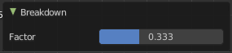
Last Operator Breakdown

Factor
The percentage of relaxing.

Blend to Neighbour
Blends the current pose with the neighbouring poses.
When you perform the tool then you will see a per cent slider in the header where you can read the percentual influence of the blending. Move the mouse to position the blend pose where you need it.

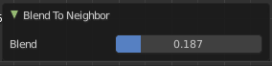
Last Operator Blend to Neighbour

Blend
The blend factor.

Blend to default Value
Blends the current pose to the default pose.
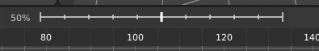
When you perform the tool then you will see a per cent slider in the header where you can read the percentual influence of the blending. Move the mouse to position the blend pose where you need it.

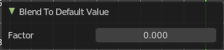
Last Operator Blend to Default

Factor
The blend factor.

Ease
Adds an ease in and ease out at the selected curves.

Blend to default Value
When you perform the tool then you will see a per cent slider in the header where you can read the percentual influence of the blending. Move the mouse to position the blend pose where you need it.

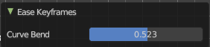
Last Operator Ease Keyframes

Factor
The blend factor.

Smooth (Gaussian)
Smoothens the selected curves with the Gaussian algorithm.

Smooth (Legacy)
Smoothens the selected curves with the legacy algorithm.

Butterworth Smooth
Smoothens the selected curves with the Butterworth algorithm.

Blend to default Value
Adds an ease in and ease out at the selected curves
When you perform the tool then you will see a per cent slider in the header where you can read the percentual influence of the blending. Move the mouse to position the blend pose where you need it.

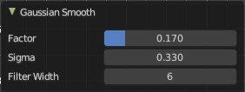
Last Operator Gaussian Smooth

Factor
The blend factor.

Sigma
The shape of the gaussian distribution. Lower values makes it sharper

Filter width
How far to each side in frames will the filter average the key values.

Clean Keyframes
Simplify FCurces by deleting keyframes that are close to each other in all channels.

Clean Channels
Simplify FCurces by deleting keyframes that are close to each other in selected channels.

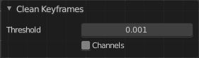
Last Operator Clean Keyframes

Threshold
The threshold amount for the simplify algorithm.

Channels
Clean keyframes or channels.

Smooth Keys
Make selected curves less bumpy.

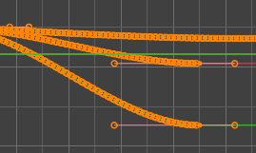
Sample Keyframes
Adds keyframes at every unit between the selected keyframes.

